Fact Sheet on
The Republic of Moldova

Map
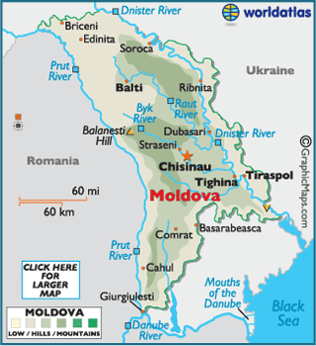
Flag

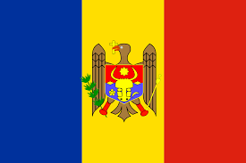

Official name: The Republic of Moldova

National Day: August 27

Capital: Chisinau

Head of State: President H.E. Mr. Igor Dodon

Head of Government: Prime Minister H.E. Mr. Ion Chicu

Foreign Minister: H.E. Mr. Aureliu Ciocoi

Political and Administrative Structure: Unitary Parliamentary democracy, Unicameral
Assembly with 101 members directly elected by proportional representation.

Administrative Divisions: 32 districts; 5 municipalities; 2 autonomous territorial units.

Area: 33,843.5 sq. km.

Density: 104.8 per sq. km (2018)

Population:3.547 million (2018)

Urban: 42.9 % (2018)

Growth rate: (-) 3.3% (2018)

Life Expectancy: 76.2 years (2016)

Literacy: 99.14% (2012)

Internet Users: 1.74 million (2014)

Other principal cities: Tiraspol, Bender, Soroca, Cricova, Ungheni, etc.

Land Boundaries: 1906 km

Railways: 1157 km (2019)

Roadways: 9359 km

Waterways: 410 km

Airports: 1

Ports and Terminals: Giurgiulesti.

GDP: $ 10.06 billion (2018)
GDP (PPP): $ 24.14 billion (2017)
GDP per capita (PPP): $ 2726 (2017)
GDP Growth: 4.0 % (2018)

Inflation rate: 2.8% (March 2019)

Pipelines: 606 km

Industrial Production Growth Rate: 6.9% (2017.)

Reserve of Foreign Exchange and Gold: $ 2.86 billion (April 2019); $ 3.041 millions worth of Gold (April 2019)

Currency: Moldovan LEU (MDL)

Exchange Rate: $1 = MDL 17.89 (approx.)

Climate: Moldova's climate is moderately continental; the summers are warm and long with temperatures averaging about 20 °C (68 °F), and the winters are relatively mild and dry with January temperatures averaging −4 °C (25 °F). Annual rainfall, which ranges from around 6 centimeters (2.4 in) in the north to 4 centimeters (1.6 in) in the south, can vary greatly; long dry spells are not unusual. The heaviest rainfall occurs in early summer and again in October; heavy showers and thunderstorms are common. Because of the irregular terrain, heavy summer rains often cause erosion and river silting.

Time: April–September: IST -2 ½ hours; October– March: IST -3 ½ hours.

Ethnic composition: Moldovan 75.1%, Romanian 7%, Ukrainian 6.6%, Gagauz 4.6%, Russian 4.1%, Bulgarian 1.9%, Roma 0.3%, other 0,5%/

Languages: Moldovan 54.6%; Romanian 24.0%; Russian 17.0%; Ukrainian 2.7%; Bulgarian 1.7%; other 0.5%;

Religion: Orthodox Christian 96.8%; Evangelical Christian Baptist 1.0 %; other 2.2%;

Imports: EUR 5.766 billion (2018); Live animals; vegetables, fats and oils of animal origin; food and beverages; tobacco; mineral products; chemical products.

Exports: EUR 2.7 billion (2018); Food and beverages; chemical products; fabrics and textiles; vegetables.

Natural Resources: Ignite, phosphorites, gypsum, limestone, arable land.

Agricultural Products: Cereals, sunflowers, sugar beets, potatoes, vegetables, tobacco, fruits, and grapes.

Major industries: Food processing (including sugar and vegetable oil) is the largest domestic industry, followed by power generation, engineering (mostly agricultural machinery, foundry equipment, refrigerators, freezers, and washing machines), hosiery, shoes, and textiles.
Major trading partners: Romania, Italy, Russia, Germany, United Kingdom.

Membership in International Organizations: BSEC, CD, CE, CEI, CIS, EAEC (observer), EAPC, EBRD, FAO, GCTU, GUAM, IAEA, IBRD, ICAO, ICC (NGOs), ICCt, ICRM, IDA, IFAD, IFC, IFRCS, ILO, IMF, IMO, Interpol, IOC, IOM, IPU, ISO (correspondent), ITU, ITUC (NGOs), MIGA, OIF, OPCW, OSCE, PFP, SELEC, UN, UNCTAD, UNESCO, UNHCR, UNIDO, Union Latina, UNMIL, UNMISS, UNOCI, UNWTO, UPU, WCO, WHO, WIPO, WMO, WTO

Indian Community: The Indian community in Moldova numbers around 400, out of which about 250 are medical students.

06 December 2019
Bucharest, Romania

